**23CSE111**

**OBJECT ORIENTED PROGRAMMING**

**LAB REPORT**



**Department of Computer Science Engineering**

**Amrita School of Computing**

**Amrita Vishwa Vidyapeetham,**

**Amaravathi**

**Name: M.N.H.O.K .MANOJ**

**Roll No: 24214**

**Verified By :**

**INDEX**

|  |  |  |  |
| --- | --- | --- | --- |
| **s.no** | **Week** | **experiment** | **Page.no** |
| **1.** | **Week-1** | **1.Installation of jdk21**  **2. Write a simple java program for printing Name, Class, Roll No, of a Student** |  |
| **2.** | **Week-2** | **1.Write a java program to find simple interest where all inputs are taken from user**  **2.Write a java program to calculate factorial of a number , read the input from user**  **3.Write a java program to calculate the Fibonacci Sequence of a input taken from user**  **4.a: Write a java program to convert temperature from Celsius to Fahrenheit**  **B: Write a java program to convert temperature from Fahrenheit to Celsius**  **5. Write a java program to calculate the area of rectangle**  **6. Write a java program to calculate the area of triangle by using heron’s formula** |  |
| **3.** | **Week-3** | **Create a java program with following instructions**  **1.Create a class with name car**  **2.Create four attributes named Car_color , Car_brand, fuel_type,mileage**  **3.Create three methods named start(),stop(),service()**  **4.Create three objects named Car1, Car2 and Car3**  **b) Create a class bankAccount with elements deposit() and Withdrawl** |  |
| **4.** | **Week-4** | a. Write a java program with class named book , the class should contain various attributes such as title , author , year of publication , it should also contain a constructor parameters which initializes title , author , year of publication  Create a method which displays details of the book  Display details of two books  b. Create a java program with class name myclass with static variable count of int type ; initialized to zero and a constant variable “pi’  Of type double initialized to 3.14 as attribute of that class , now define a constructor for “ my class “ that increment the count variable each time an object of my class is created count = 0 ,finally print the final values of “count” ans pi variable ,create 3 objects |  |
| **5.** | **Week-5** | **a)create a calculator using the operation including adding, subtraction,multiplication,and division using multilevel inheritance and display desired output**  **every class one method (int a ,int b)**  **pass values as parameter during ,method call** |  |
| **6.** | **Week-6** | **a: Write a java program to create a vehicle class with a method displayInfo().Override this method in the car subclass to provide specific information a about car**  **b: A college is developing an automated admission system that verifies student eligibility for UG and PG programs. Each program has different eligibility criteria based on the student’s percentage in their previous Qualification:**  **UG admissions require a minimum of 60%**  **PG admissions require a minimum of 70%**  **C: AIM : Create a Shape class with a method calculateArea() that is overloaded forDifferent shapes. Then, create a subclass circle that overrides the calculateArea() method for a circle**  **D: . Create a calculator class with overloaded methods to perform addition**   1. **Add two integers 2. Add two doubles 3. Add three integers** |  |
| **7.** |  |  |  |
|  |  |  |  |
|  |  |  |  |

**WEEEK -1 (LAB )**

1. **Process of Installing JDK (Java Development Kit)**

**Installing JDK (Java Development Kit):**

* 1. **Download JDK:**
* **Go to the Oracle JDK download page in google and click on JDK-21 version which is Long term support (LTS) version.**
* **Click the download link as your operating system (Windows, macOS, or Linux).** 
  1. **Install JDK:**
* **Once downloaded, run the installer.**
* **Follow the given instructions and keep clicking "Next" until it is done.** 
  1. **Set Environment Variables (Windows):**
* **Open file explorer, then right click on This PC next select on properties then it will take you to the settings app then click on advanced system settings and then click on Environment Variables.**
* **Click on path and new under System Variables:**

**Variable value: The folder address where JDK is installed (like**

**C:\Program Files\Java\jdk-21\bin)**

* **Find Path under System Variables, click New, and add the path of the jdk-21(C:\Program Files\Java\jdk-21\bin)**

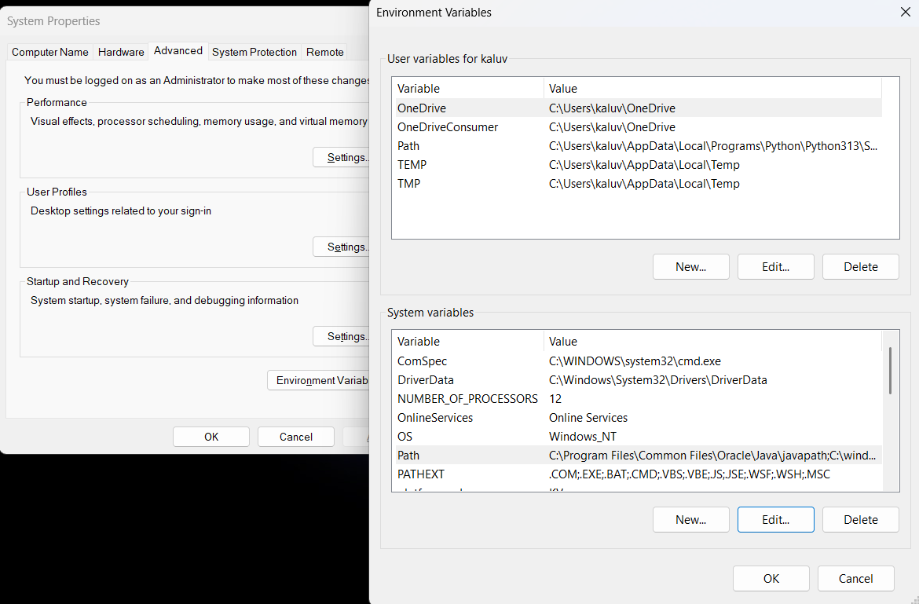

**Checking JDK Version: -**

* 1. **Open Command Prompt:**
* **Presswin+R, typecmd, and press Enter.** 
  1. **Check Version:**
* **Type java -version and press Enter.**
* **Type javac --version and press Enter.**

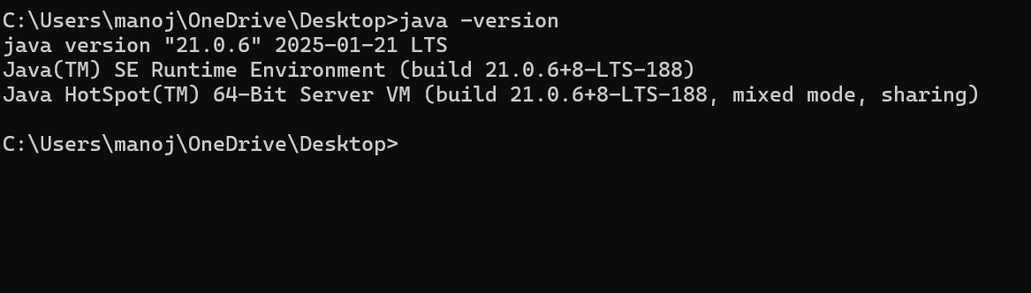

1. **Simple Java Program for printing Name, Class, Roll No, of a Student**

Write your code in Notepad and execute it in cmd prompt

**CODE: -**

Class manoj

**{**

**public static void main(String[] args)**

**{**

**System.out.println("Name: M.N.H.O.K. MANOJ ");**

**System.out.println("CLASS: CSE");**

**System.out.println("SECTION:C");**

**}**

**}**

**Output: -**

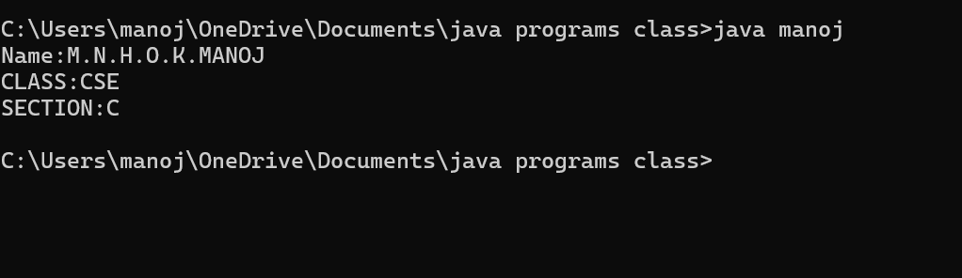

Errors:

|  |  |  |
| --- | --- | --- |
| 1 | Syntax error | Semicolon added |
| 2 | Runtime error | Copied correct path |
| 3 | Name error | rectified |

**WEEK -2 (LAB)**

**SIMPLE JAVA programs**

1. **AIM:**

**Write a java program to write area of rectangle.**

**Important points: AREA OF RECTANGLE IS AREA = LENGTH * BREATH**

**Code:**

class demo {

public static void main(string[] args) {

Scanner sc = new Scanner(System.in);

System.out.println(“enter a number:”);

int l = sc.nextInt();

System.out.println(“enter a number;”);

int b = sc.nextInt();

int a = l*b;

System.out.println(“area of rectangle is “+a);

}

**}**

**Output :**

**1.Positive case**

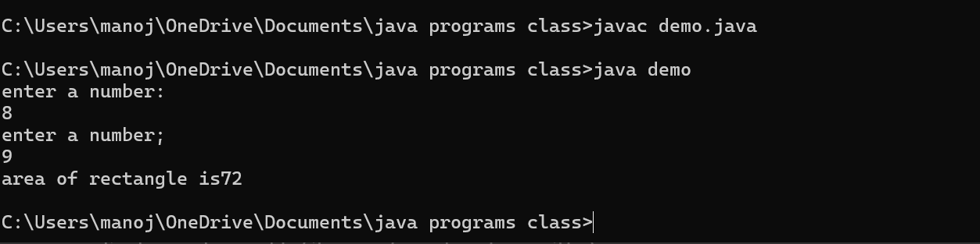

**2.Negative case :**

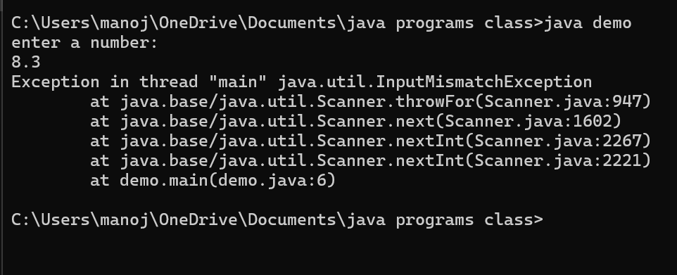

**Errors table :**

|  |  |  |
| --- | --- | --- |
| 1 | Syntax error | Semicolon added |
| 2. | Name error | rectified |

1. **AIM :**

**Write a java program to find simple intrest where all input from user**

**Code :**

import java.util.*;

class test{

public static void main(String[] args)

{

System.out.println(" taking input");

Scanner sc = new Scanner(System.in);

System.out.println("enter INTa number:");

float p = sc.nextFloat();

System.out.println("enter a number:");

float t = sc.nextFloat();

System.out.println("enter a num:");

float r = sc.nextFloat();

float s = (p*t*r)/100;

System.out.println("simple intrest is"+s);

}

}

**Output:**

1. Positive case :

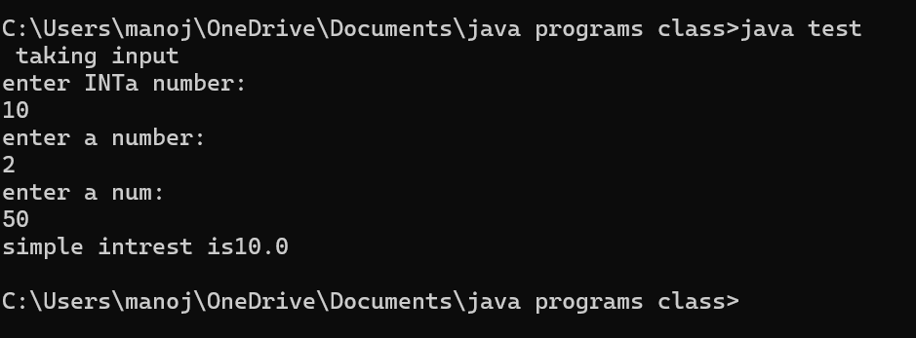

1. **Negative case :**

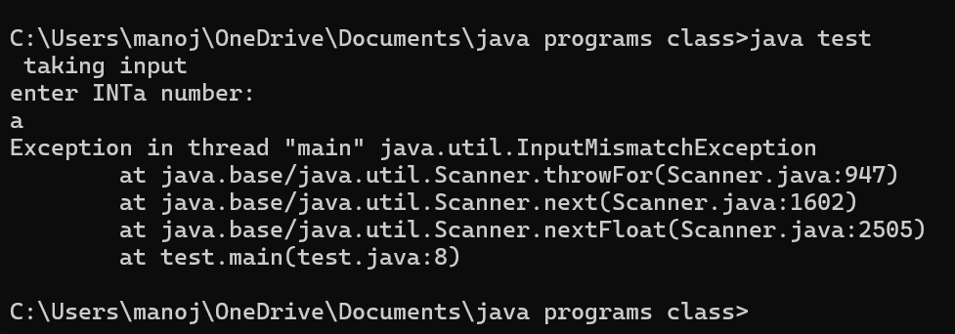

**Error table :**

|  |  |  |  |
| --- | --- | --- | --- |
| **S.No** | **Error type** | **Reason for error** | **rectification** |
| **1** | **Runtime error** | **Incorrect path** | **Copied correct path** |
| **2** | **Syntax error** | **Using incorrect symbols** | **Using correct symbols** |
| **3** | **Logical error** | **Wrong formula** | **Formula rectified** |

1. **Fibonacci sequence to caculate Fibonacci sequence read from user .**

**Important points:**

**Code:**

Import java.util.*;

class zeebra

{

public static void main(String args[])

{

Scanner sc = new Scanner(System.in);

int num;

int f3;

int f1 = 0;

int f2 = 1;

int i = 2;

System.out.print("Enter a number:");

num = sc.nextInt();

System.out.println(f1);

System.out.println(f2);

while(i<num)

{

f3 = f1+f2;

f1 = f2;

f2 = f3;

System.out.println(f3);

i = i+1;

}

}

}

**1.Positive case :**

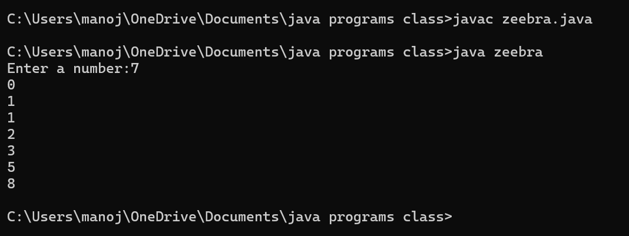

**2.Negative case :**

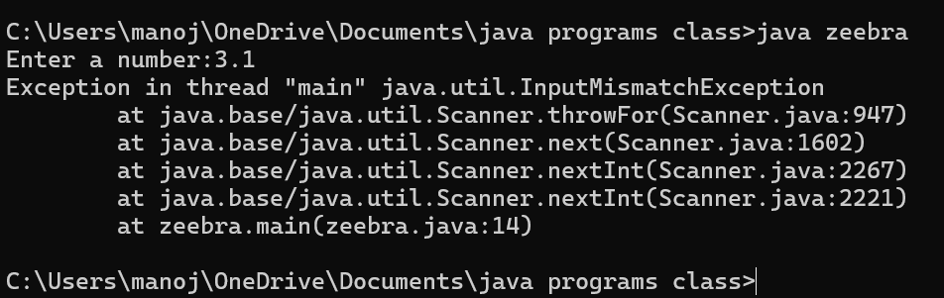

**Error table :**

|  |  |  |  |
| --- | --- | --- | --- |
| **S.No** | **Error type** | **Reason for error** | **Rectification** |
| **1** | **Logical error** | **Incorrect formula** | **Using correct formula** |
| **2** | **Syntax error** | **Incorrect symbols** | **Using correct symbols** |
| **3** | **Runtime error** | **Incorrect path** | **Copied correct path** |

1. **AIM: write a java program to convert temperature from fahrenheat to celcius**

**Code :**

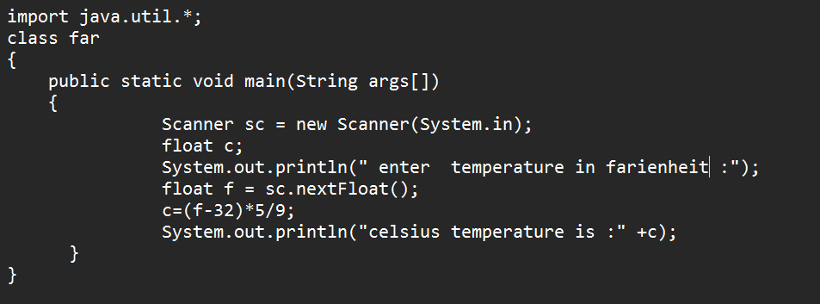

OUTPUT:

1. Positive case :

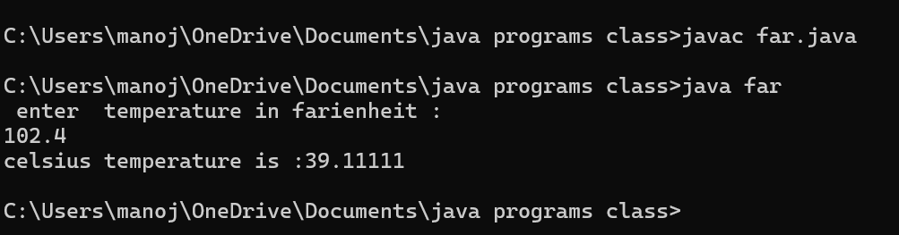

**2.negative case:**

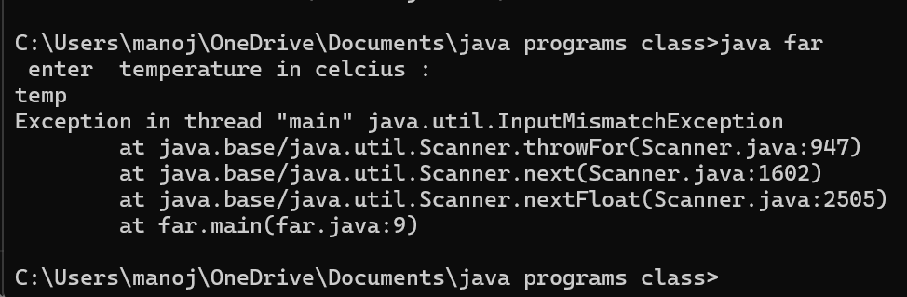

|  |  |  |  |
| --- | --- | --- | --- |
| **S.No** | **Error type** | **Reason for error** | **rectification** |
| **1.** | **Syntax** | **Incorrect symbol** | **Using correct symbols** |
| **2.** | **Logical error** | **Due to incorrect formula** | **Corrected by giving correct formula** |
| **3.** | **Runtime error** | **Incorrect path** | **Using correct path** |

**AIM:**

**Write a java program to calculate factorial of a number read from user**

**Code:**

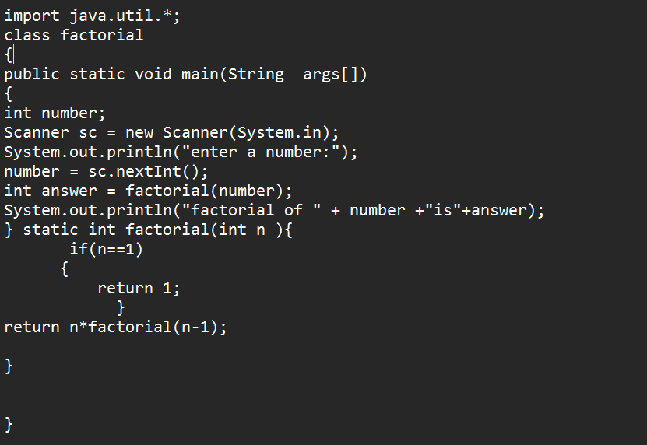

Output:

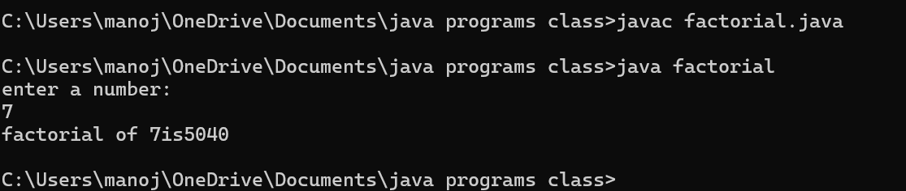1.Positive case :

2.Negative case:

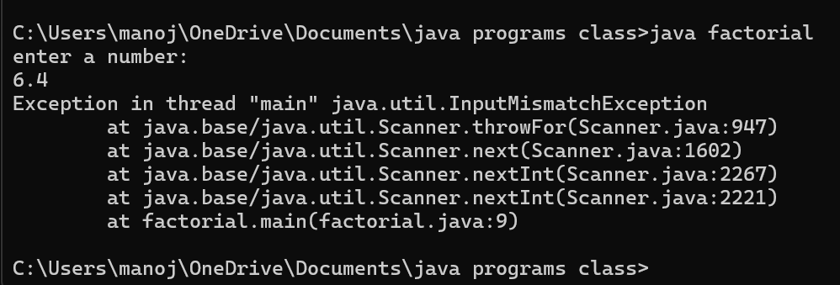

**Error table:**

|  |  |  |  |
| --- | --- | --- | --- |
| **S.No** | **Error type** | **Reason for error** | **rectification** |
|  | **Logical error** | **Incorrect formula** | **Correcting formula** |
|  | **Runtime error** | **Incorrect path** | **Using correct path** |
|  | **syntax** | **Incorrect symbols** | **Using correct symbols** |

**6. AIM:Write a Java program to convert temperature from celcius to farenheit:**

**Code:**

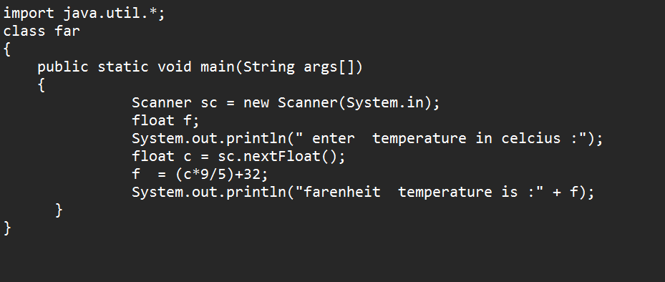

Output:

1. Positive case :

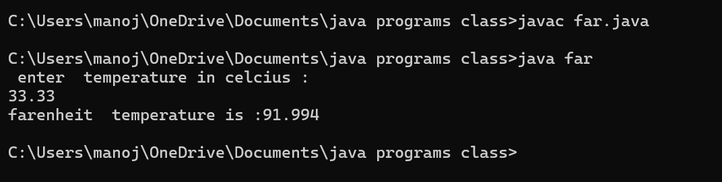

1. 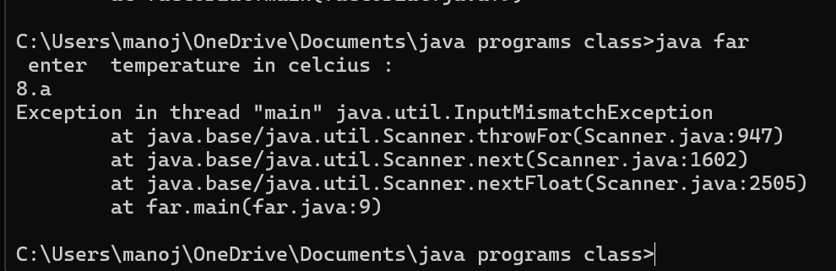Negative case:

Error table:

|  |  |  |  |
| --- | --- | --- | --- |
| **S.No** | **Error type** | **Reason for error** | **rectification** |
| **1.** | **Logical error** | **Incorrect formula** | **Correcting formula** |
| **2.** | **Runtime errror** | **Incorrect path** | **Using correct path** |
| **3.** | **Syntax error** | **No symbols** | **Using correct symbols** |

1. **AIM:**

**Write a Java program to find area of triangle using herons’s formula :**

**Import points:**

**Code:**

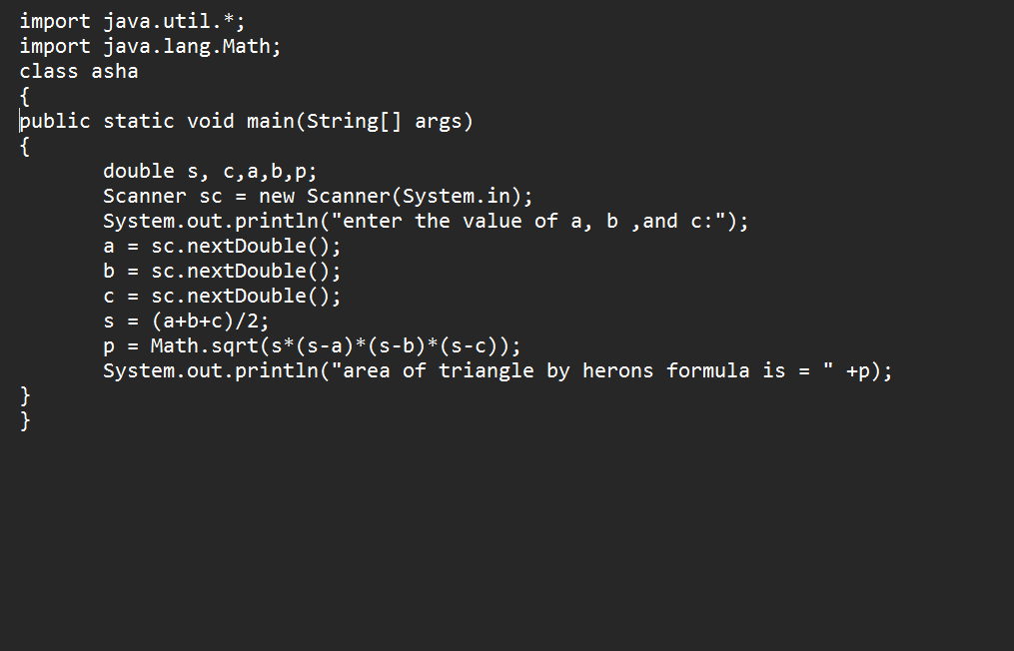Output:

1.Positive case :

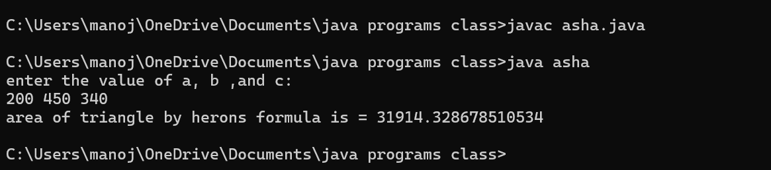

2.Negative case :

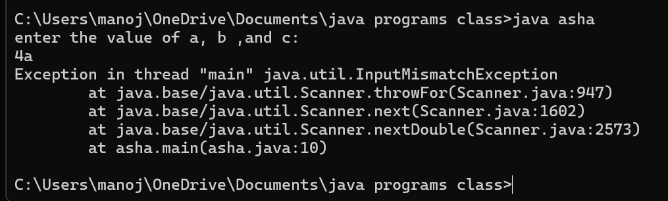

**Error table:**

|  |  |  |  |
| --- | --- | --- | --- |
| **S.No** | **Error type** | **Reason for error** | **rectification** |
| **1.** | **Logical error** | **Incorrect formula** | **Correcting formula** |
| **2.** | **Runtime errror** | **Incorrect path** | **Using correct path** |
| **3.** | **Syntax error** | **Incorrect symbols** | **Using correct symbols** |

**Week -3(lab)**

1. AIM:

To create java program with following instructions :

1. Create a class with name car
2. Create four attributes named car_color ,car_brand,

Fuel_type, milage

1. Create three methods named start(),stop(),service()
2. Create three objects named car1 ,car2 ,car3.

**IMPORTANT POINT:**

1. **CONSTRUCTOR:** A constructor in Java is a special method that is used to initialize objects. It is automatically called when an object of a class is created.

**Key Features of a Constructor:**

1. Same Name as the Class: The constructor name must be the same as the class name.
2. No Return Type: Constructors do not have a return type (not even void).
3. Called Automatically: It runs automatically when an object is created.

**ATTRIBUTES:**

In Java, attributes (also called fields or instance variables) are used to store the state or properties of an object**.**

**METHODS:**

**A method in Java is a block of code that performs a specific task. It is used to increase code reusability, modularity, and maintainability**

**Code :**

**import java.util.*;**

**class car**

**{**

**public String color;**

**public String brand;**

**public String fuel;**

**public int mileage;**

**public void start()**

**{**

**System.out.println("Car Started:");**

**System.out.println("Car color is :"+color);**

**System.out.println("Car Brand is:"+brand);**

**System.out.println("Car fuel type is:"+fuel);**

**System.out.println("Car mileage is:"+mileage);**

**}**

**public void service()**

**{**

**System.out.println("Car Service:");**

**System.out.println("Car color is :"+color);**

**System.out.println("Car Brand is:"+brand);**

**System.out.println("Car fuel type is:"+fuel);**

**System.out.println("Car mileage is:"+mileage);**

**}**

**public void stop()**

**{**

**System.out.println("Car Stop:");**

**System.out.println("Car color is :"+color);**

**System.out.println("Car Brand is:"+brand);**

**System.out.println("Car fuel type is:"+fuel);**

**System.out.println("Car mileage is:"+mileage);**

**}**

**public static void main(String args[])**

**{**

**car car1 = new car();**

**car1.color = "Black";**

**car1.brand = "MARUTHI";**

**car1.fuel = "Deisel";**

**car1.mileage = 80;**

**car1.start();**

**car car2 = new car();**

**car2.color = "BLUE";**

**car2.brand = "hundai";**

**car2.fuel = "petrol";**

**car2.mileage = 120;**

**car2.stop();**

**car car3 = new car();**

**car3.color = "maroon";**

**car3.brand = "shift";**

**car3.fuel = "deisel";**

**car3.mileage = 100;**

**car3.service();**

**}**

**}**

**Output :**

**1.Positive case**

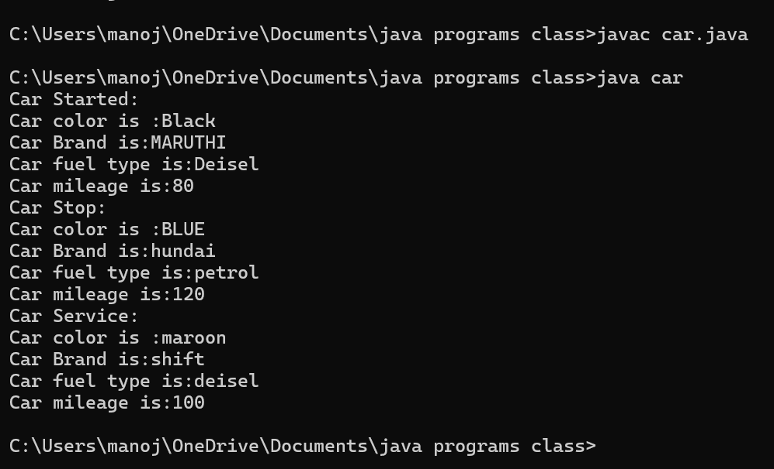

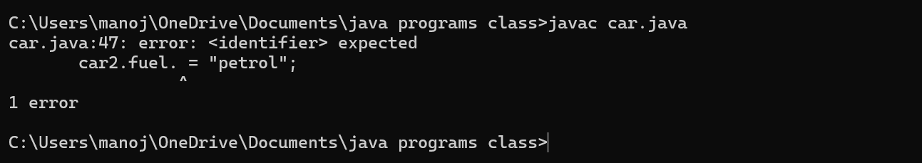**2.Negative case**

**Error table:**

|  |  |  |  |
| --- | --- | --- | --- |
| **S.No** | **Error type** | **Reason for error** | **rectification** |
| **1.** | **Logical error** | **Incorrect formula** | **Correcting formula** |
| **2.** | **Runtime errror** | **Incorrect path** | **Using correct path** |
| **3.** | **Syntax error** | **Incorrect symbols** | **Using correct symbols** |

**CLASS DIAGRAM:**

|  |
| --- |
| **Class Name = Car** |
| **Attributes :**  **-Color= String**  **-Brand = String**  **- Fuel = String**  **-Milage= Int** |
| **Methods**  **+Start():Void**  **+Stop():Void**  **+Service() :Void** |
|  |

1. **AIM:**

**TO CREATE A CLASS BANK ACCOUNT WITH METHODS DEPOSIT() AND WITHDRAWL()**

**CODE:**

class BankAccount {

public String Acchname;

public int Accnumber;

public double curramount;

// Constructor to initialize account details

BankAccount(String Acchname, int Accnumber, double curramount) {

this.Acchname = Acchname;

this.Accnumber = Accnumber;

this.curramount = curramount;

System.out.println("Account Created:");

System.out.println("Account Holder: " + Acchname);

System.out.println("Account Number: " + Accnumber);

System.out.println("Current Balance: $" + curramount);

System.out.println("---------------------------");

}

// Method to withdraw money

public void withdraw(double withdraw) {

if (withdraw > curramount) {

System.out.println("Insufficient Funds!");

} else {

curramount -= withdraw;

System.out.println("Withdrawn: $" + withdraw);

System.out.println("Updated Balance: $" + curramount);

}

System.out.println("---------------------------");

}

// Method to deposit money

public void deposit(double deposit) {

curramount += deposit;

System.out.println("Deposited: $" + deposit);

System.out.println("Updated Balance: $" + curramount);

System.out.println("---------------------------");

}

// Main method

public static void main(String args[]) {

// Creating a bank account object

BankAccount account1 = new BankAccount("krishna manoj", 116117, 100089.0);

// Performing transactions

account1.d

account1.withdraw(300);

account1.withdraw(1000500); // Should show "Insufficient Funds"

}

}

**OUTPUT:**

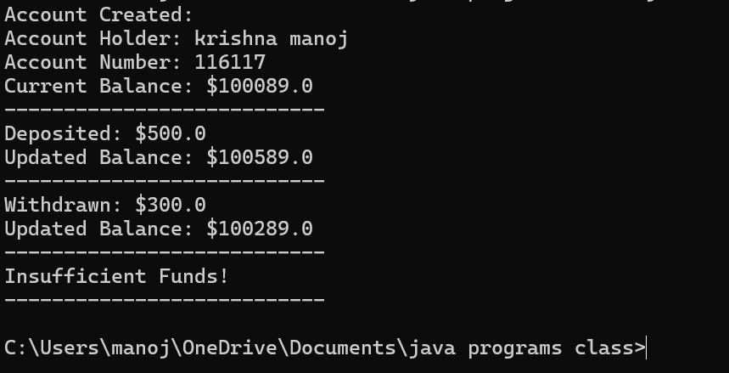**1.POSITIVE CASE:**

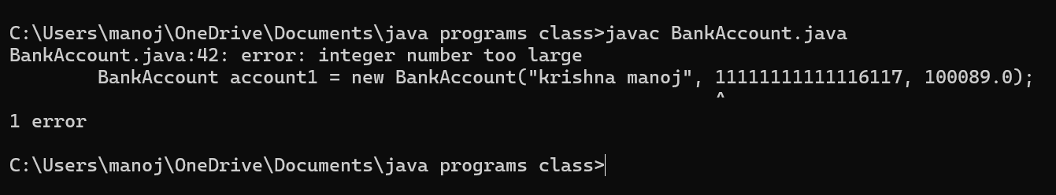**2. NEGATIVE CASE:**

**Error table:**

|  |  |  |  |
| --- | --- | --- | --- |
| **S.No** | **Error type** | **Reason for error** | **rectification** |
| **1.** | **Logical error** | **Incorrect formula** | **Correcting formula** |
| **2.** | **Runtime errror** | **Incorrect path** | **Using correct path** |
| **3.** | **Syntax error** | **Incorrect symbols** | **Using correct symbols** |

**CLASS DIAGRAM:**

|  |
| --- |
| **CLASS = BankAccount** |
| **ATTRIBUTES:**  **- Acchname: String**  **- Accnumber: int**  **- curramount: double** |
| **METHODS:**  **+ BankAccount(Acchname: String, Accnumber: int, curramount: double)**  **+ Withdrawl:Void**  **+Deposit :Void** |
|  |

**WEEK – 4 (LAB)**

1. **AIM:**

**Write a java program with class named book ,the class should contain various attributes such as title , author , year of publication , it should also contain a constructor parameters which initializes title , author , year of publication**

**Create a method which displays details of the book**

**Display details of two books**

**Syntax:**

import java.util.*;

class book

{

public String title;

public String author;

public int year;

public void ashabhosle()

{

System.out.println(" book - ashabhosle:");

System.out.println("the title is :"+title);

System.out.println("THE NAME OF AUTHOR : " +author);

System.out.println("YEAR OF PUBLICATION :"+year);

System.out.println("-------------------------------------------");

}

public void kishorekumar()

{

System.out.println(" book -kishorekumar:");

System.out.println("the title is :"+title);

System.out.println("THE NAME OF AUTHOR : " +author);

System.out.println("YEAR OF PUBLICATION :"+year);

System.out.println("-------------------------------------------");

}

public static void main(String args[])

{

book book1 = new book();

book1.author = " R .K .NARAYAN " ;

book1.title = " MALGUDI DAYS " ;

book1.year = 1953;

book1.ashabhosle() ;

book book2 = new book();

book2.author = " MOHMMAD RAFI ";

book2.title = " VOICE OF INDIA - ASHA BHOSLE" ;

book2.year = 1972;

book2.kishorekumar();

}

}

**Output:**

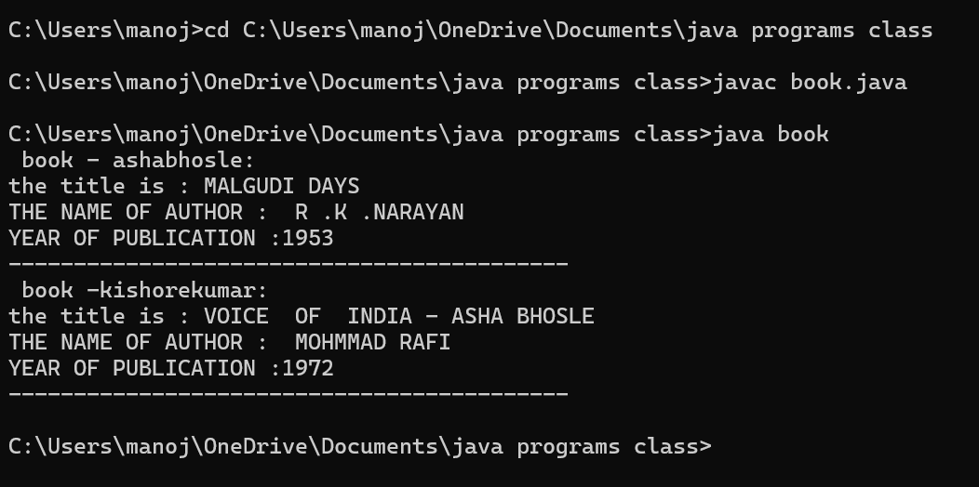**1.Positive cases :**

**2.Negative case :**

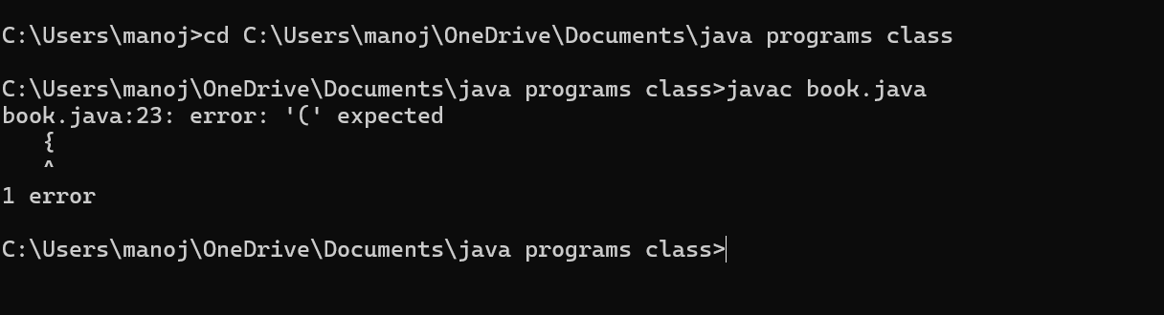

**ERROR TABLE:**

|  |  |  |  |
| --- | --- | --- | --- |
| **S.No** | **Error type** | **Reason for error** | **rectification** |
| **1.** | **Logical error** | **Incorrect formula** | **Correcting formula** |
| **2.** | **Runtime errror** | **Incorrect path** | **Using correct path** |
| **3.** | **Syntax error** | **Incorrect symbols** | **Using correct symbols** |

**Class diagram:**

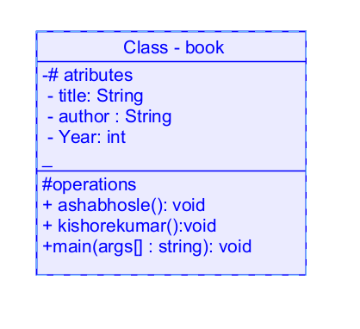

**2.AIM:**

**Create a java program with class name myclass with static variable count of int type ; initialized to zero and a constant variable “pi’**

**Of type double initialized to 3.14 as attribute of that class , now define a constructor for “ my class “ that increment the count variable each time an object of my class is created count = 0 ,finally print the final values of “count” ans pi variable ,create 3 objects**

**Code:**

class myclass

{

static int count=0;

final double pi=3.14;

myclass()

{

count = count+1;

}

public void set()

{

System.out.println("Count is:"+count);

System.out.println("Pi value is:"+pi);

}

public static void main(String args[])

{

myclass m = new myclass();

System.out.println(count);

m.set();

myclass n = new myclass();

System.out.println(count);

n.set();

myclass l = new myclass();

System.out.println(count);

l.set();

System.out.println("Final count is:"+count);

System.out.println(m.pi);

}

}

Output:

1.positive case:

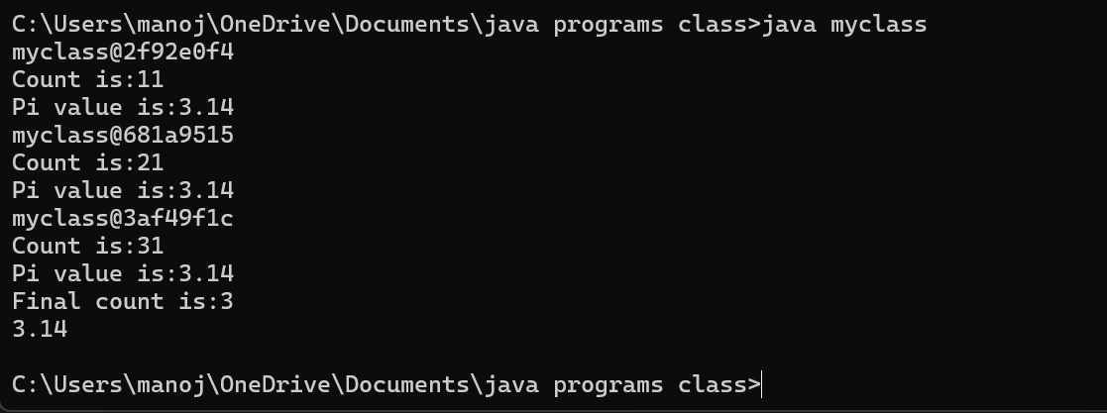

2.negative case:

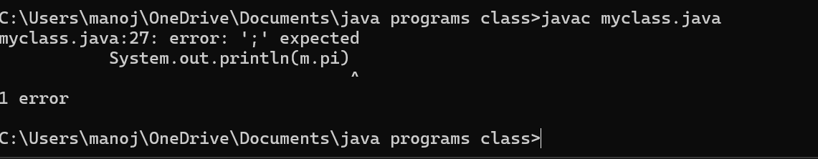

Error table:

|  |  |  |  |
| --- | --- | --- | --- |
| **S.No** | **Error type** | **Reason for error** | **rectification** |
| **1.** | **Logical error** | **Incorrect formula** | **Correcting formula** |
| **2.** | **Runtime errror** | **Incorrect path** | **Using correct path** |
| **3.** | **Syntax error** | **Incorrect symbols** | **Using correct symbols** |

Class diagram :

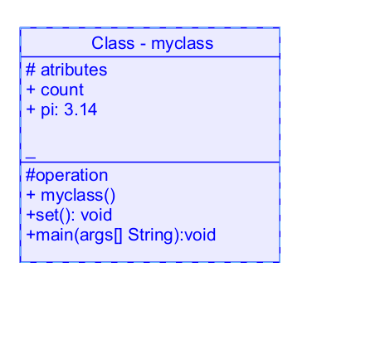

**Week -5**

**Aim:**

1. **create a calculator using the operation including adding, subtraction,multiplication,and division using multilevel inheritance and display desired output**

**every class one method (int a ,int b)**

**pass values as parameter during method call**

**important points :**

1. **used contructor and ssigned values as int a and int b.**
2. **used multilevel unheritance .**
3. **used this keyword to assign values .**

**program:**

**class addition{**

**public int add(int a, int b){**

**System.out.println("addition is done in calculator below:");**

**System.out.println("");**

**int addition = a+b;**

**return addition;**

**}**

**}**

**class subtraction extends addition {**

**public int sub(int a, int b){**

**System.out.println("subtraction is done in calculator below:");**

**System.out.println("");**

**int subtraction = a-b;**

**return subtraction;**

**}**

**}**

**class multiplication extends subtraction**

**{**

**public int mult(int a, int b) {**

**System.out.println("multiplication is done in calculator below:");**

**System.out.println("");**

**int multiplication = a*b;**

**return multiplication;**

**}**

**}**

**class division extends multiplication{**

**public int div(int a,int b){**

**System.out.println("divission is done in calculator below:");**

**System.out.println("");**

**int division = a/b;**

**return division;**

**}**

**}**

**class calculator**

**{**

**public static void main(String args[])**

**{**

**division obj = new division();**

**addition img = new addition();**

**subtraction del = new subtraction();**

**multiplication zym = new multiplication();**

**System.out.println("Addition is:"+ img.add(99,1));**

**System.out.println("-----------------------------------");**

**System.out.println ("Subtraction is:"+del.sub(200,100));**

**System.out.println("-----------------------------------");**

**System.out.println("Multiplication is:"+zym.mult(50,2));**

**System.out.println("-----------------------------------");**

**System.out.println("Division is:"+obj.div(1000,10));**

**System.out.println("**************************************");**

**}**

**}**

**Output:**

1. **positive case:**

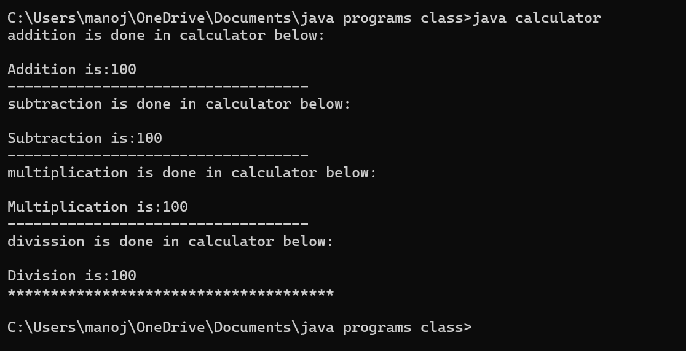

1. negative case:

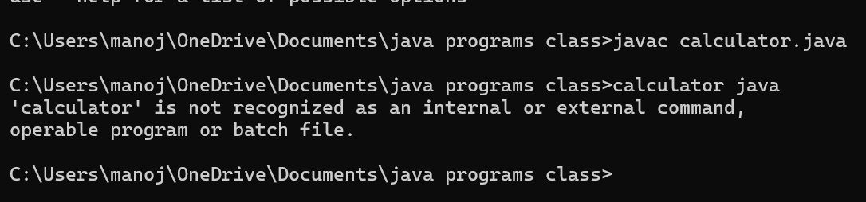

**Error table:**

|  |  |  |  |
| --- | --- | --- | --- |
| **S.No** | **Error type** | **Reason for error** | **rectification** |
| **1.** | **Logical error** | **Incorrect formula** | **Correcting formula** |
| **2.** | **Runtime errror** | **Incorrect path** | **Using correct path** |
| **3.** | **Syntax error** | **Incorrect symbols** | **Using correct symbols** |

**Classs diagram:**

|  |
| --- |
| **Class : addition** |
| **+ add( int a ,int b)** |
|  |

|  |
| --- |
| **Class : subtraction** |
| **+ sub( int a ,int b)** |

|  |
| --- |
| **Class : multiplication** |
| **+ multi( int a ,int b)** |

|  |
| --- |
| **Class : divission** |
| **+ div( int a ,int b)** |

**B: aim:**

**A vehicle rental company wants to develop a system that maintains Information about different types of vehicles available for rent The Company rents out cars, bikes and truck and they need a program to Store details about each vehicle, such as brand and speed Cars should have an additional property: number of doors Bikes should have a property indicating whether they have gears or not The system should also include a function to display details about each vehicle And indicate when a vehicle is starting**

Program:

class vehicle{

String brand;

int speed;

public vehicle(String brand,int speed){

this.brand=brand;

this.speed=speed;

}

public static void main(String[] args) {

car obj1=new car("maruti",133,7);

bike obj2=new bike("unicorn",75,true);

truck obj3=new truck("zimban",120,16);

}

}

class car extends vehicle{

int noofdoors;

public car(String brand, int speed,int noofdoors) {

super(brand, speed);

this.noofdoors=noofdoors;

System.out.println(brand);

System.out.println(speed);

System.out.println(noofdoors);

}

}

class bike extends vehicle{

boolean gears;

public bike(String brand,int speed,boolean gears){

super(brand, speed);

this.gears=gears;

System.out.println(brand);

System.out.println(speed);

System.out.println(gears);

}

}

class truck extends vehicle{

int weight;

public truck(String brand,int speed,int weight){

super(brand,speed);

this.weight=weight;

System.out.println(brand);

System.out.println(speed);

System.out.println(weight);

}

public static void main(String[] args) {

car obj1=new car("maruti",133,7);

bike obj2=new bike("unicorn",75,true);

truck obj3=new truck("zimban",120,16);

}

}

**Out put:**

**1.positive case :**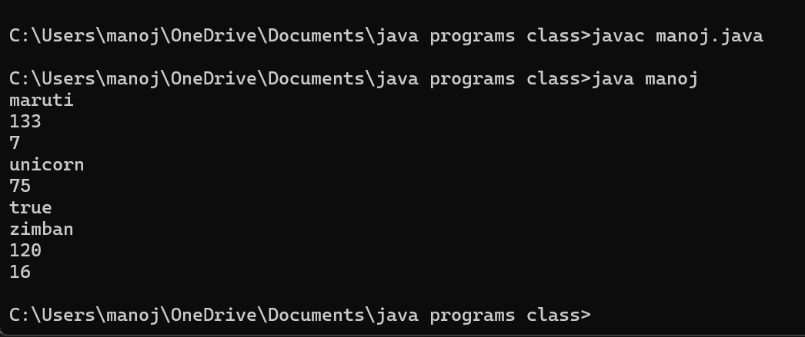

2.negative case: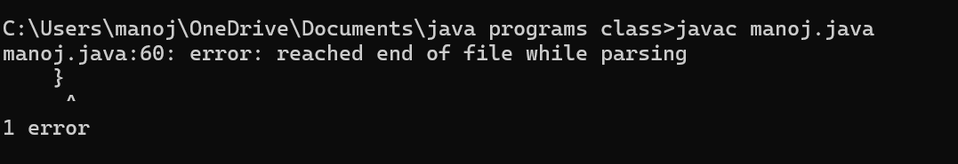

Error table:

|  |  |  |  |
| --- | --- | --- | --- |
| **S.No** | **Error type** | **Reason for error** | **rectification** |
| **1.** | **Logical error** | **Incorrect formula** | **Correcting formula** |
| **2.** | **Runtime errror** | **Incorrect path** | **Using correct path** |
| **3.** | **Syntax error** | **Incorrect symbols** | **Using correct symbols** |

Class diagram:

|  |
| --- |
| Class vehicle |
| + brand:string  + speed :int |
| Vehicle(String brand ,int speed) |

|  |
| --- |
| Class car |
| +noofdoors:int |
| car(String brand ,int speed ,noofdoors) |

|  |
| --- |
| Class bike |
| + gear : bool |
| bike(String brand ,int speed,Boolean grars) |

|  |
| --- |
| Class truck |
| + weight:int |
| truck(String brand ,int speed) |

**Important points:**

1.Inheritance:

Obtaining the qualities from parent class.

2.hirechial inheritance: different child class obtaing qualities from one parent.

Week- 6:

1. Aim:

**Write a java program to create a vehicle class with a method displayInfo().Override this method in the car subclass to provide specific information a about car**

**Code:**

class Vehicle {

String brand;

int speed;

int capacity;

Vehicle(String brand, int speed, int capacity) {

this.brand = brand;

this.speed = speed;

this.capacity = capacity;

}

public void displayInfo() {

System.out.println("Vehicle Details:");

System.out.println("--------------------------------");

System.out.println("Brand: " + brand);

System.out.println("Speed: " + speed + " km/h");

System.out.println("Capacity: " + capacity + " people");

}

}

class Car extends Vehicle {

Car(String brand, int speed, int capacity) {

super(brand, speed, capacity);

}

public void displayInfo() {

System.out.println("Car Details:");

System.out.println("--------------------------------");

System.out.println("Brand: " + brand);

System.out.println("Speed: " + speed + " km/h");

System.out.println("Capacity: " + capacity + " people");

}

}

public class world {

public static void main(String[] args) {

Vehicle vehicle = new Vehicle("Luna", 78, 5);

vehicle.displayInfo();

System.out.println();

Car car = new Car("bonda", 120, 7);

System.out.println("car details are given below :");

car.displayInfo();

}

}

OUT PUT :

1.POSITIVE CASE :

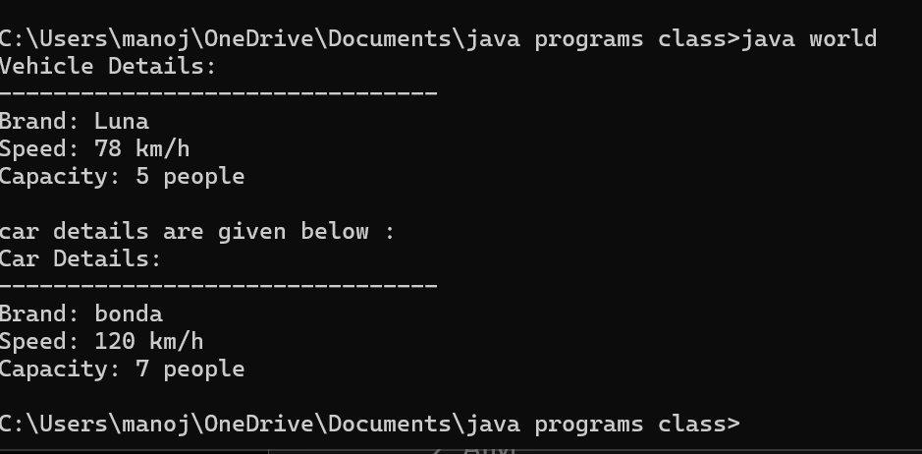

2.NEGATIVE CASE :

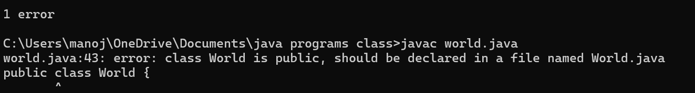

CLASS DIAGRAM:

|  |
| --- |
| CLASS VEHICLE |
| ATTRIBUTES :  + SPEED  + BRAND  + CAPACITY |
| +DISPLAYINFO():void  + VEHICLE (INT ,SPEED INT CAPACITY ,STRING BRAND) |

|  |
| --- |
| class car |
| car(int speed ,int capacity ,string brand)  displayinfo() : void |

Important points:

1. **Inheritance** allows the Car class to reuse the Vehicle class functionality without repeating code.

2. **Method Overriding** enables the Car class to provide its own implementation of the displayInfo() method.

3. **Polymorphism** makes the code flexible, allowing different classes (e.g., Car, Bike) to provide customized behavior for displayInfo().

2.AIM:

A college is developing an automated admission system that verifies student eligibility for UG and PG programs. Each program has different eligibility criteria based on the student’s percentage in their previous Qualification:

UG admissions require a minimum of 60%

PG admissions require a minimum of 70%

Code:

class University {

String name;

int percentile;

University(String name, int percentile) {

this.name = name;

this.percentile = percentile;

}

public void office() {

System.out.println("Admission criteria are mentioned below.");

}

}

class PG extends University {

PG(String name, int percentile) {

super(name, percentile);

}

public void office() {

if (percentile >= 70) {

System.out.println(name + " is eligible for PG admission.");

} else {

System.out.println(name + " is not eligible for PG admission.");

}

}

}

class UG extends University {

UG(String name, int percentile) {

super(name, percentile);

}

public void office() {

if (percentile >= 60) {

System.out.println(name + " is eligible for UG admission.");

} else {

System.out.println(name + " is not eligible for UG admission.");

}

}

}

public class admissions {

public static void main(String[] args) {

UG ugStudent = new UG("krishna", 95);

PG pgStudent = new PG("manoj", 96);

ugStudent.office();

pgStudent.office();

}

}

Output :

1.positive case :

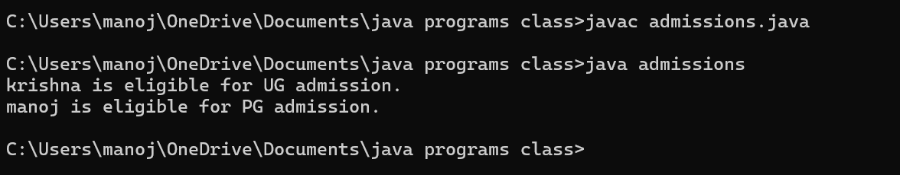

2.negative case :

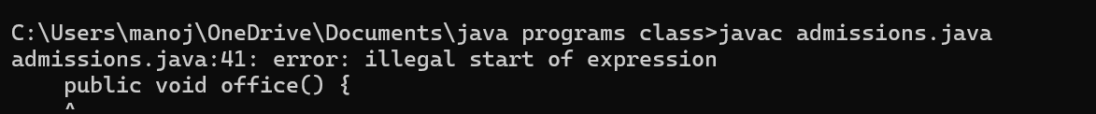Error table:

|  |  |  |  |
| --- | --- | --- | --- |
| **S.No** | **Error type** | **Reason for error** | **rectification** |
| **1.** | **Logical error** | **Incorrect formula** | **Correcting formula** |
| **2.** | **Runtime errror** | **Incorrect path** | **Using correct path** |
| **3.** | **Syntax error** | **Incorrect symbols** | **Using correct symbols** |

Class diagram :

|  |
| --- |
| University |
| - name: String  - percentile: int |
| + University(String, int)  + office(): void |

|  |
| --- |
| PG |
| + PG(String, int)  + office(): void |

|  |
| --- |
| UG |
| + UG(String, int)  + office(): void |

|  |
| --- |
| admissions |
| + main(String[]): void |

IMPORTANT POINTS:

1.**Inheritance** allows PG and UG classes to reuse the University class’s attributes and constructor.

2. **Method Overriding** customizes the office() method in PG and UG classes to implement specific admission criteria.

3. **Polymorphism** enables the same office() method to behave differently for PG and UG objects based on their typ

3.AIM : Create a Shape class with a method calculateArea() that is overloaded forDifferent shapes. Then, create a subclass circle that overrides the calculateArea() method for a circle

CODE:

class Shape {

public void calculateArea(int length, int width) {

int area = length * width;

System.out.println("Area of Rectangle: " + area);

}

public void calculateArea(double base, double height) {

double area = 0.5 * base * height;

System.out.println("Area of Triangle: " + area);

}

public void calculateArea(int side) {

int area = side * side;

System.out.println("Area of Square: " + area);

}

}

class Circle extends Shape {

public void calculateArea(double radius) {

double area = 3.14 * radius * radius;

System.out.println("Area of Circle: " + area);

}

}

public class area {

public static void main(String[] args) {

Shape shape = new Shape();

shape.calculateArea(5, 45);

shape.calculateArea(7.0, 34.0);

shape.calculateArea(7);

Circle circle = new Circle();

circle.calculateArea(15.0);

}

}

Out put:

1.positive case :

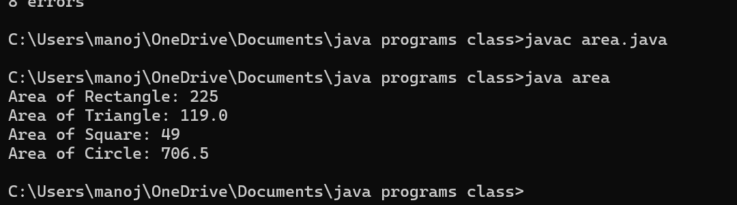

1. Negative case :

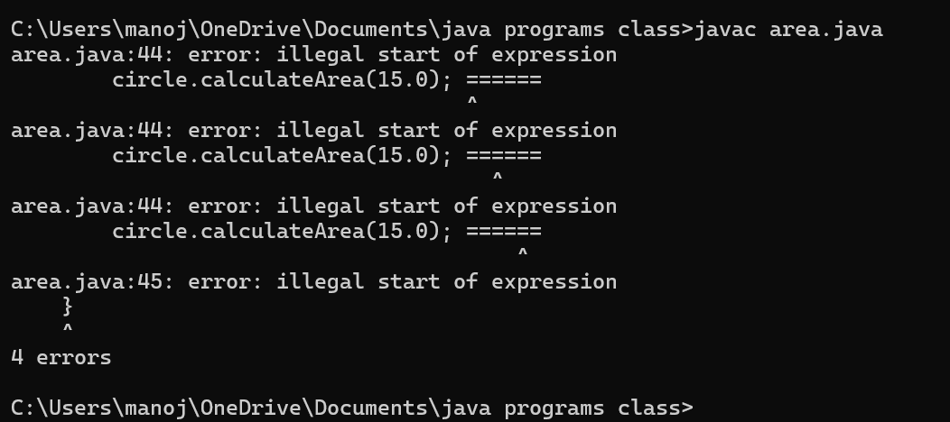

Error table:

|  |  |  |  |
| --- | --- | --- | --- |
| **S.No** | **Error type** | **Reason for error** | **rectification** |
| **1.** | **Logical error** | **Incorrect formula** | **Correcting formula** |
| **2.** | **Runtime errror** | **Incorrect path** | **Using correct path** |
| **3.** | **Syntax error** | **Incorrect symbols** | **Using correct symbols** |

**Claas diagram :**

|  |
| --- |
| **Class shapes** |
| **+ calculateArea(int, int): void**  **+ calculateArea(double, double): void**  **+ calculateArea(int): void** |

|  |
| --- |
| Class circle |
| + calculateArea(double): void |

|  |
| --- |
| Area |
| + main(String[]): void |

IMPORTANT POINTS :

1. **Method Overloading** allows the Shape class to calculate areas for different shapes (rectangle, triangle, square) using multiple calculateArea() methods with different parameters.
2. **Method Overriding** in the Circle class provides a custom implementation of calculateArea() for calculating the area of a circle.
3. **Polymorphism** enables objects of different types (e.g., Shape, Circle) to call the appropriate version of calculateArea() based on the object type and input parameters.

4**. Create a calculator class with overloaded methods to perform addition**

1. **Add two integers 2. Add two doubles 3. Add three integers**

**CODE:**

**class calculatorman**

**{**

**public int add(int a, int b)**

**{**

**System.out.println(" addition of in type: ");**

**return a+b;**

**}**

**public double add(double a, double b)**

**{ System.out.println(" addition of double type: ");**

**return a+b;**

**}**

**public int add(int a, int b, int c)**

**{**

**System.out.println(" addition of int type 3 variables: ");**

**return a+b+c;**

**}**

**}**

**class HOSTEL**

**{**

**public static void main(String args[]){**

**calculatorman kaala = new calculatorman();**

**System.out.println("Addition of 100 and 100 is:"+kaala.add(100,100));**

**System.out.println("Addition of 99.3 and 0.7 is:"+kaala.add(99.3 , 0.7));**

**System.out.println("Addition of 7 7 7 is:"+kaala.add(7,7,7));**

**System.out.println(" did by : M.N.H.O.K.Manoj");**

**}}**

**OUTPUT:**

* 1. **POSITIVE CASE :**

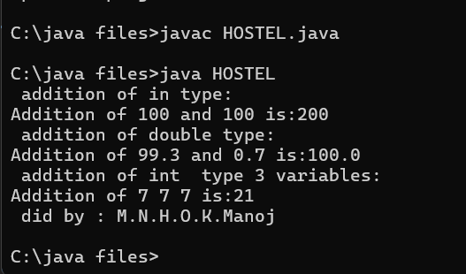

* 1. 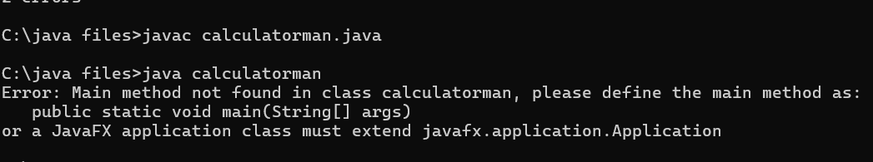**NEGATIVE CASE :**

**ERROR TABLE :**

|  |  |  |  |
| --- | --- | --- | --- |
| **S.No** | **Error type** | **Reason for error** | **rectification** |
| **1.** | **Logical error** | **Incorrect formula** | **Correcting formula** |
| **2.** | **Runtime errror** | **Incorrect path** | **Using correct path** |
| **3.** | **Syntax error** | **Incorrect symbols** | **Using correct symbols** |

CLASS DIAGRAM:

|  |
| --- |
| CLASS CALCULATORMAN |
| +add(int, int): int  +add(double, double): double + +add(int, int, int): int |
|  |

|  |
| --- |
| HOSTEL |
| +main(String[]): void |